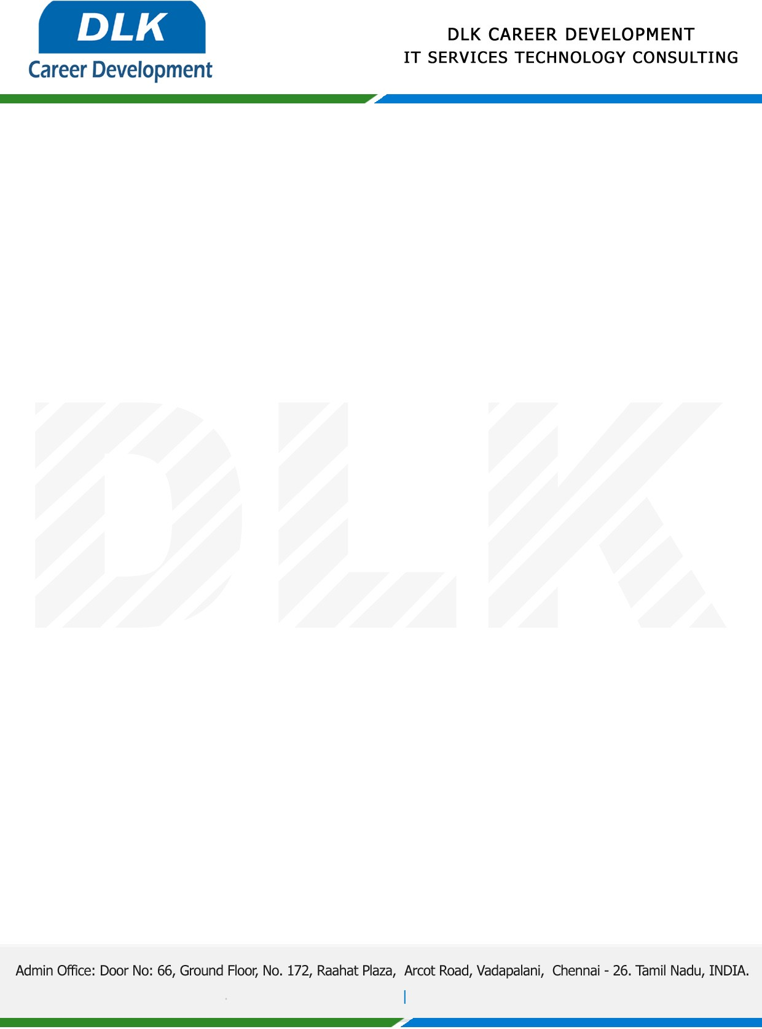

Date: 01/ July/ 2022

**To**

MCA- Computer Application,

Head of Department,

University of Madras, Chennai.

**Sub: Letter of Project Acceptance**

This is to certify that **MS** **KAVITHA M (REG NO: C21101PCA6192)** Final year student has accepted the Project Work duration from **July 2022 to December 2022**

**Domain:** Java

**Topic:** Patient Health care system

During the Project Work, all information and data collected from you should be kept confidential.

We appreciate your interest in **DLK CAREER DEVELOPMENT**

